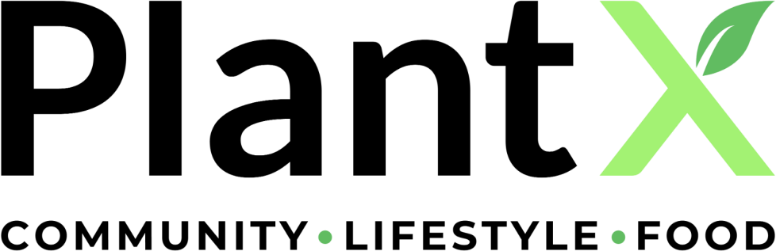

PLANTX LIFE INC.
MANAGEMENT DISCUSSION AND ANALYSIS
For the year ended March 31, 2023 and 2022

504 - 100 Park Royal South
West Vancouver, British Columbia, V7T 1A2 Tel: (604) 355-6100

This management discussion and analysis (“MD&A”) is to accompany the consolidated financial statements of PlantX Life Inc. (“PlantX” or the “Company”) for the year ended March 31, 2023 and 2022.

This MD&A is dated July 27, 2023.

The following MD&A should be read in conjunction with the financial statements of the Company for the year ended March 31, 2023 and 2022 and with the audited consolidated financial statements and the notes thereto for the year ended March 31, 2023, which were prepared in accordance with International Financial Reporting Standards (“IFRS”). Unless otherwise noted, all currency amounts are in Canadian dollars.

Management is responsible for the information contained in the MD&A and its consistency with information presented, reviewed and approved by the audit committee of the Company (the “Audit Committee”) and board of directors of the Company (the “Board”).

FORWARD-LOOKING STATEMENTS

Certain statements contained in this MD&A constitute forward-looking statements. All statements other than statements of historical fact may be forward-looking statements. Forward-looking statements are often, but not always, identified by the use of words such as “seek”, “anticipate”, “plan”, “continue”, “estimate”, “designed”, “expect”, “may”, “will”, “project”, “predict”, “potential”, “targeting”, “intend”, “could”, “might”, “should”, “believe” and similar expressions. These statements are subject to a variety of risks and uncertainties which could cause actual events or results to differ from those reflected in the forward-looking statements. Based on current available information, the Company believes that the expectations reflected in those forward-looking statements are reasonable, but no assurance can be given that those expectations will prove to be correct. The forward-looking statements in this MD&A are expressly qualified by this statement, and readers are advised not to place undue reliance on the forward-looking statements.

DESCRIPTION OF THE BUSINESS

Overview

The Company is incorporated under the laws of the province of British Columbia. PlantX was formerly an exploration stage company engaged in the acquisition and exploration of mineral resource properties in Canada.

On August 5, 2020, the Company completed the acquisition of privately-held PlantX Living Inc. (formerly PlantX Life Inc.) (“PlantX Living”). The acquisition constituted a reverse takeover of the Company and the Company would carry on the business of PlantX Living (the “RTO Transaction”). Pursuant to the RTO Transaction, the Company changed its name from “Winston Resources Inc.” to “Vegaste Technologies Corp.”

On September 28, 2020, the Company changed its name to “PlantX Life Inc.” PlantX is a reporting issuer in the jurisdictions of British Columbia, Alberta and Ontario and lists its common shares

(“Common Shares”) for trading on the Canadian Securities Exchange (“CSE”) under the symbol “VEGA”, on the OTCQB® Venture Market under the symbol “PLTXF” and on the Frankfurt Stock Exchange under the symbol “WNT1”.

The head office of the Company is located at 504-100 Park Royal South, West Vancouver, BC, V7T 1A2, Canada.

Strategy

PlantX is primarily an e-commerce company specializing in an extensive range of plant-based brands, available on its comprehensive "one-stop shop for everything plant-based" online platforms. The Company’s e-commerce channels serve as a trusted source for high-quality plant-based products, encompassing groceries, ingredients, food and beverages, cosmetics, pet foods, and plants. With a remarkable selection, PlantX offers more than 5,000 plant-based products to customers throughout North America via its e-commerce websites.

Operating under a direct shipping model, PlantX seamlessly facilitates the delivery of goods directly from its warehouses to end-point consumers. This streamlined approach ensures a swift and efficient process for customers who place orders. Additionally, PlantX proudly serves as a reliable shipping fulfillment solution for renowned plant-based brands that face logistical challenges. By redirecting their websites to PlantX.com, the company benefits from increased search engine optimization (SEO) and enhanced website sales, all while leveraging outside effective marketing activities at no cost to PlantX.

Additionally, the Company, under its wholly-owned subsidiary Bloomboxclub Limited (“Bloombox Club”), also operates its business relevant to Bloombox Club using a supply-chain management system known as “dropshipping” whereby Bloombox Club facilitates the delivery of the goods from a third-party manufacturer to a third party distributor and then to the end-point consumer who places the associated order. Dropshipping typically does not require Bloombox Club to own inventory. Strategically, dropshipping enables the company’s business operates with limited overhead and inventory, thus maximizing margins and, ultimately, net profit. During the year ended March 31, 2023, the Company’s management focused on building certain verticals, including, but not limited to, Bloombox Club, XMarket Chicago and Little West.

During the year ended March 31, 2023, the company placed a significant focus on bolstering profitability by nurturing its high-growth sectors and making necessary adjustments to underperforming business units that didn't meet the stringent margin thresholds.

To optimize operations, the company made the strategic decision to close two Canadian locations inside the Hudson’s Bay (Yorkdale, Toronto and Rideau Ottawa) due to insufficient foot traffic. All inventory from these stores was transferred to the Chicago warehouse, making it available for purchase on both PlantX.com and VeganEssentials.com. Additionally, the equipment from these locations was repurposed for the XMarket uptown store.

XMarket Uptown is currently undergoing construction as the company embarks on the creation of Chicago's pioneering Vegan Foodhall. With all necessary permits obtained and successful inspections completed, the highly anticipated opening is scheduled around Labor Day. The Vegan Foodhall will

showcase six local vegan restaurants, accompanied by a coffee shop run by PlantX's Portfolio Coffee brand, and a fully licensed bar offering an extensive selection of vegan-friendly beverages.

In an effort to enhance efficiency and customer experience, the company consolidated XMarket Squamish and the Cloudburst Coffee shop at the Locavore Bar and Grill. This move allowed for the expansion of the lounge area, providing customers with a more inviting space to spend time onsite. As a result, daily sales increased, and the company gained additional revenue opportunities through hosting private events.

The company's focused approach on profitability yielded positive results, particularly in the transformation of BloomBox Club. The team size was reduced from 30 to 4 employees, positioning BloomBox Club on the verge of achieving profitability.

With the addition of Chris Dodigovic overseeing operations, the company's cold-pressed juice vertical, Little West, experienced continued expansion. Under Chris's leadership, Little West successfully expanded to Northern California, Nevada, Montana, and structured a deal with Dr. Munsch to bring the juices to the East Coast.

The Venice Beach location continued to experience growth and excitement through successful popup initiatives. Notably, TiNDLE extended its 3-month popup for an additional 3 months, further driving customer engagement and sales.

In terms of e-commerce, the company further strengthened its relationship with KEHE. Leveraging KEHE's inventory, the company offered consumers case packs of every single plant-based item carried by KEHE, including frozen and refrigerated products. This offering, in addition to the company's own curated assortment of vegan products shipped from the Chicago warehouse, contributed to increased sales and customer satisfaction.

Geo Lopez was promoted to logistics manager at the Chicago warehouse. Geo's expertise in shipping cold products and his ability to source materials at the lowest possible costs played a crucial role in ensuring products reached end customers in optimal condition. As the company forges ahead, profitability remains a central focus, driving growth, expansion, and success across its diverse business units. The company is committed to delivering exceptional experiences within the plant-based industry while continually striving for improvement.

PlantX has recently entered into a share exchange agreement with a newly formed Cayman Islands corporation to Secure Additional Funding and Further Grow its U.S. Operations. Under this agreement, PlantX will exchange a selection of its assets, including wholly owned subsidiaries Vegaste Technologies US Corp., Little West LLC, Plant Based Deli LLC, and PlantX Living Inc., as well as its 53% interest in Portfolio Coffee, Inc. and 51% interest in Eh Coffee Corp. Upon completion of the transaction, it is anticipated that PlantX will own approximately 60% of the issued and outstanding shares of the newly formed corporation, referred to as NewCo, with any adjustments dependent on the NewCo Financing.

OPERATIONAL HIGHLIGHTS

On March 8, 2022, Bloombox Club expanded its direct to consumer indoor plant selling business into Austria https://bloomboxclub.at/.

On March 28, 2022, Bloombox Club expanded its direct to consumer indoor plant selling business to Ireland https://bloomboxclub.ie/.

On April 25, 2022, PlantX launched a new ecommerce platform to establish a direct to consumer business for Portfolio Coffee https://portfoliocoffee.ca/

On April 26, 2022, Bloombox Club expanded its direct to consumer indoor plant selling business to France https://bloomboxfrance.fr/.

On April 28, 2022, PlantX announced the launch of its Multi-Brand Pop-Up RetaiI Initiative and Obtains
$2 Million Convertible Loan.

On June 2, 2022, PlantX announced that it received authorization to sell and distribute alcoholic beverages in its U.S. retail stores in Chicago, Illinois and Venice Beach, California

On July 4, 2022, PlantX announced partnership with Dream Pops as a popup tenant at the Venice Beach location.

On September 12, 2022, PlantX announced partnership with Future Farm as a popup tenant at the Venice Beach location.

On September 19, 2022, PlantX announced its plans to acquire the longest standing vegan ecommerce platform veganessentials.com

On September 21, 2022, PlantX announced the effective date for share consolidation.

On October 3, 2022, PlantX announced that it will take on ecommerce fulfillment for The Very Good Food Company.

On October 17, 2022, PlantX completes the acquisition of VeganEssentials.com

On January 18, 2023, PlantX announced partnership with Minor Figures as a popup tenant at the Venice Beach location.

On February 14, 2023, PlantX announced that it will take on ecommerce fulfillment for Nowadays plant based nuggets.

On March 2, 2023, PlantX announced that it will take on ecommerce fulfillment for No Evil Foods.

On March 16, 2023, PlantX announced that the company entered into a share exchange agreement to secure additional funding and further grow its US operations.

On March 22, 2023, PlantX Enters into Strategic Ecommerce Partnership with VeganWines.com

PLANTX ONLINE PLATFORM

The Company’s online platforms are as follows;

PlantX.com / PlantX.ca (https://plantx.com/, https://plantx.ca/)

PlantX.com and PlantX.ca are inclusive online platforms catering to individuals interested in adopting a plant-based lifestyle, including flexitarians and those who may feel hesitant due to the political side of veganism. These platforms aim to empower users with knowledge and education, without imposing any political agenda. PlantX is here to make the transition to a plant-based lifestyle accessible, enjoyable, and free from judgment.
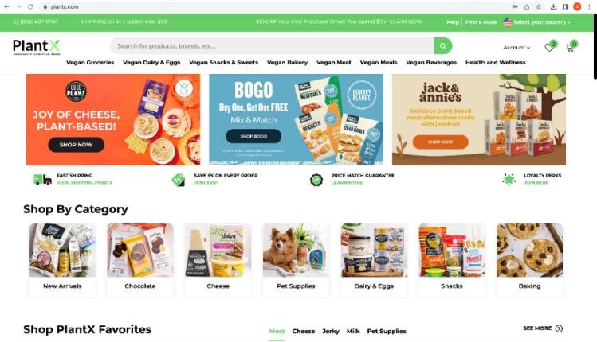
Vegan Essentials (https://veganessentials.com/)

VeganEssentials.com, the oldest domain in the vegan industry, is a haven for both old school and new wave vegans who are deeply mission-driven. As pioneers in the vegan world, these customers have witnessed significant changes in the industry over time, and VeganEssentials has remained a steadfast partner throughout their journey. With an unwavering commitment to providing the widest variety of vegan products available online, VeganEssentials caters to the unique needs and preferences of its diverse customer base.
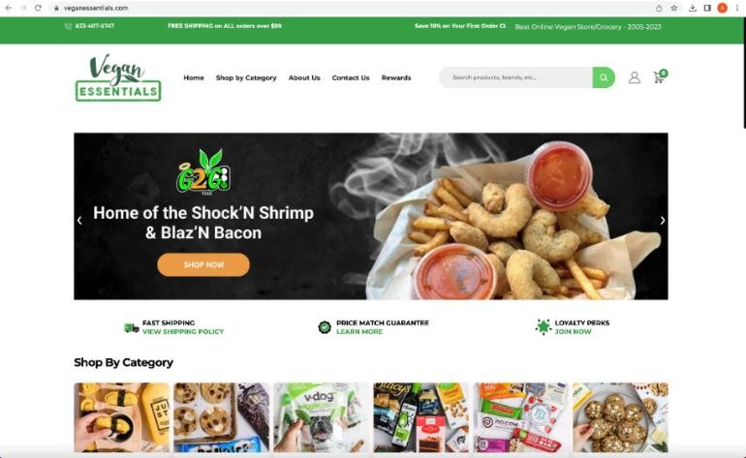

LittleWest.com (https://littlewest.com/)

LittleWest.com is a flourishing cold pressed juice company that has garnered immense popularity throughout Southern California. With its robust wholesale business, it has become well-known for delivering cold-pressed juices directly to consumers' doorsteps. Under PlantX's management, the website has experienced impressive growth month over month. Excitingly, Little West wholesale business is gearing up for expansion and has ambitious plans to reach every state by 2024.
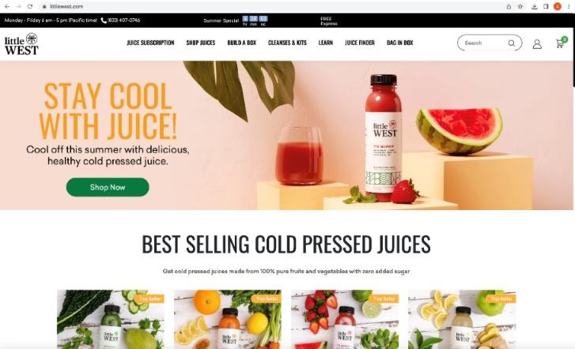

Portfolio Coffee https://portfoliocoffee.ca/

Portfolio Coffee brings the world of premium coffee to its customers' doorsteps. With a direct sourcing approach, Portfolio Coffee curates high-quality beans from renowned farms across the globe. Hand- roasted fresh in their Toronto, Canada roastery, their coffee is delivered straight to customers via this ecommerce platform.
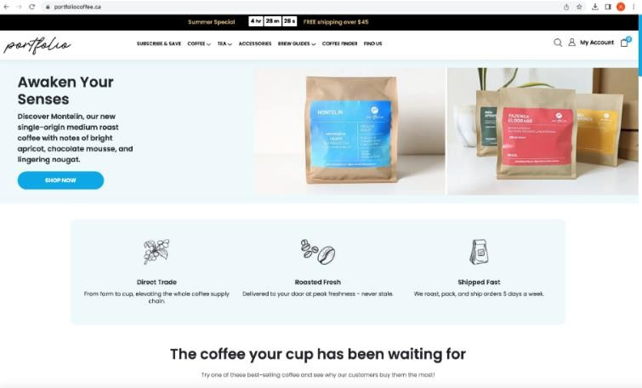

EH Coffee (https://ehroasters.com/)

EH Roasters is a specialty coffee company that prioritizes the wholesale side of the industry. With a strong emphasis on traceability, they directly source beans from farms, ensuring a transparent supply chain at Eh Coffee. Moreover, they offer private label solutions to numerous coffee shops in the Toronto area, tailoring their offerings to suit each unique brand.
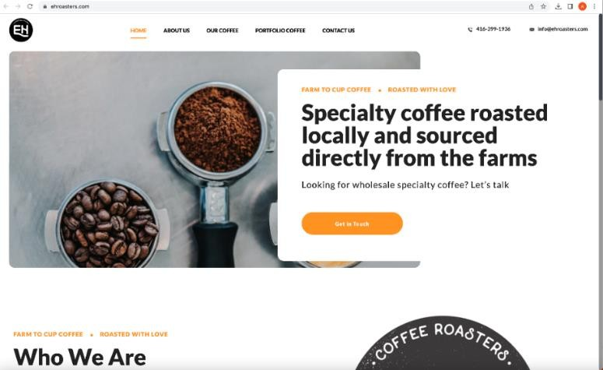

BloomboxClub (https://bloomboxclub.com/)

Bloombox Club is an online platform, offering a curated selection of indoor plants and unique botanical accessories. With a passion for green living and the positive impact of nature, Bloombox Club empowers plant enthusiasts to transform their spaces into green sanctuaries. Their hand- picked collection of plants is not only aesthetically pleasing but also scientifically proven to improve air quality and overall well-being.
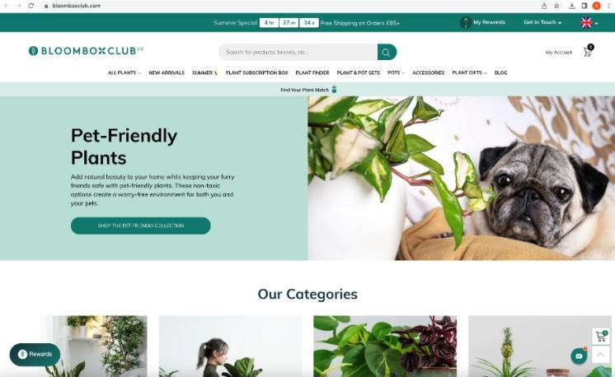

The Locavore Bar & Grill (https://locavorebarandgrill.com/)

At Locavore Bar and Grill, the fusion of a delectable food truck, lively bar, and artisanal coffee shop creates an unforgettable experience, centered around community, flavor, and sustainability.
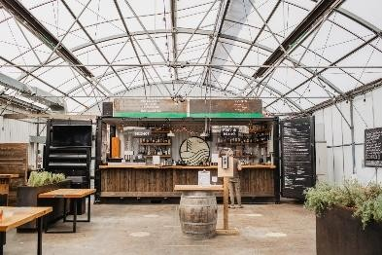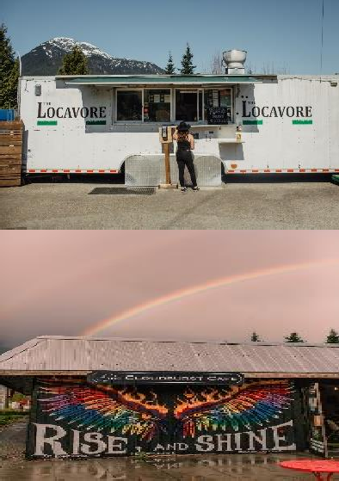

XMarket Store in Venice Beach:
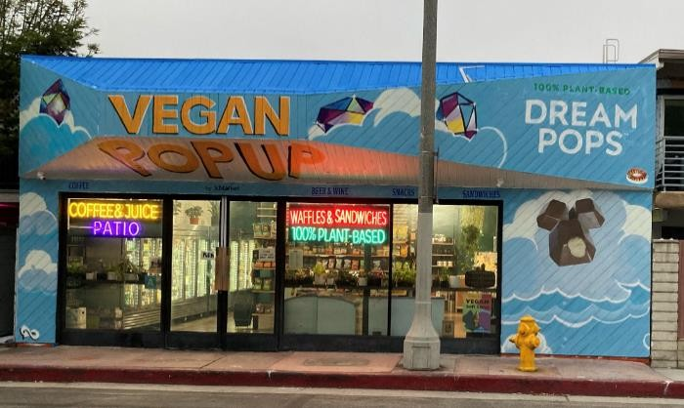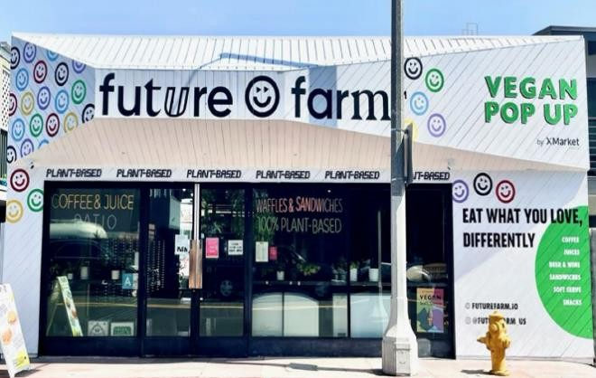
(Dream Pops Pop Up Collaboration) (Future Farm Pop Up Collaboration)
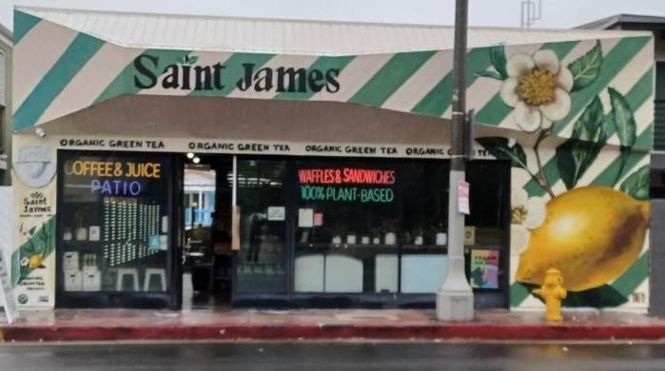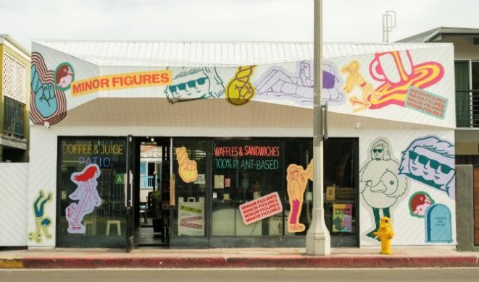
(Saint James Iced Tea Pop Up Collaboration) (Minor Figures Pop Up Collaboration)
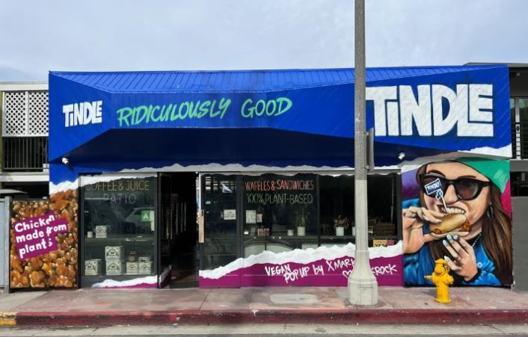
(TiNDLE Pop Up Collaboration)

FINANCIAL STATEMENTS GOING CONCERN ASSUMPTION

The consolidated financial statements of the Company have been prepared on the basis of accounting principles applicable to a going concern under IFRS. The use of these principles under IFRS assumes that the Company will continue in operation for the foreseeable future and will be able to realize assets and discharge its liabilities in the normal course of operations. The Company incurs operating losses, which casts significant doubt about the Company’s ability to continue as a going concern.

Management’s current strategy is careful cost control while pursuing opportunities within various market sectors. Management recognizes the Company’s need to increase its cash reserves in the coming year if it intends to adhere to its plans and has evaluated its potential sources of funds. Although management intends to assess and act on these options throughout the course of the year, there can be no assurance that the steps management takes will be successful.

In the event that cash flow from operations, together with the proceeds from any future financings are insufficient to cover planned expenditures, management will allocate available resources in such manner as deemed to be in the Company’s best interest. This may result in a significant reduction in the scope of existing and planned operations.

During the year ended March 31, 2023, the Company generated revenue of $13,299,891 (March 31, 2022 - $11,984,809) and as of March 31, 2023 had a net loss of $21,384,656 (March 31,2022
$54,802,666) excluding share based compensation of $274,502 (March 31, 2022 - $10,964,662) and impairment of nil (March 31, 2022 - $ 19,201,131). The revenue growth of $1,315,082 compared to the same period of the prior year was driven by increasing sales on the e-commerce sites along with the strategic acquisitions that were able to service customer needs by providing food and plant deliveries to homes and other businesses.

In assessing whether the going concern assumption is appropriate, management takes into account all available information about the future, which is at least, but not limited to, twelve months from the end of the reporting period. Management is aware, in making its assessment, of uncertainties related to events or conditions that may cast significant doubt upon its ability to continue as a going concern that these uncertainties are material and, therefore, that it may be unable to realize its assets and discharge its liabilities in the normal course of business.

Accordingly, the consolidated financial statements do not give effect to adjustments that would be necessary, should the Company be unable to continue as a going concern and therefore to realize its assets and discharge its liabilities and commitments in other than the normal course of business and at amounts different from those in the accompanying consolidated financial statements. These adjustments could be material.

SUMMARY OF FINANCIAL RESULTS

 | 31-Mar | 31-Dec | 30-Sep | 30-Jun | 31-Mar
 | 2023 | 2022 | 2022 | 2022 | 2022
Revenue | 2,009,769 | 2,420,543 | 3,853,855 | 5,015,724 | 4,354,316
Cost of sales | (1,233,935) | (1,435,076) | (2,323,673) | (3,218,440) | (3,820,041)
Net Loss | (7,923,852) | (4,496,585) | (3,753,802) | (5,210,417) | (28,624,557)
Basic and diluted loss per share | (0.63) | (3.57) | (2.98) | (4.14) | (22.75)
Total Assets | 7,554,463 | 10,696,207 | 11,608,258 | 11,656,717 | 12,195,192
Total liabilities | 25,617,388 | 24,028,839 | 20,168,847 | 17,438,676 | 13,195,797

RESULTS OF OPERATIONS

Period from April 1, 2022, to March 31, 2023

During the year ended March 31, 2023, the Company reported a net loss of $21,384,656 of which
$274,502 was the result of share-based compensation and a loss per share of $ 16.90. The Company incurred $536,140 in accounting and audit fees in the normal course of operations, $2,795,328 in advertising and promotion, $3,579,857 in amortization and depreciation, $3,780,924 in consulting and management fees, $5,613,914 in general and administrative expenses, $348,619 in insurance expense,
$1,299,072 in legal fees, $5,192,144 in salaries expense, $139,142 in transfer agent and filing fees,
$265,689 in travel expense, $(248,504) other loss, earned $10,376 in foreign exchange gain, and incurred
$(780,821) in interest expense.

During the year ended March 31, 2022, the Company reported a net loss of $54,802,666 of which
$10,964,662 was the result of share-based compensation and a loss per share of $8.36. The Company incurred $374,569 in accounting and audit fees in the normal course of operations, $6,289,840 in advertising and promotion, $1,343,668 in amortization and depreciation, $4,878,889 in consulting and management fees, $1,211,933 in general and administrative expenses, $213,853 in insurance expense, $1,294,470 in legal fees, $4,801,446 in salaries expense, $196,978 in transfer agent and filing fees, $824,460 in travel expense, $284,033 in transaction cost, $19,201,131 in impairment of goodwill,
$1,264,733 other loss,$2,056,765 loss from acquisition of LIV assets, earned $101,307 in foreign exchange gain, and incurred $254,345 in interest expense and earned $127,012 in other income, and earned $246,479 fair value adjustment of contingent consideration.

Advertising and promotion decreased significantly compared to the same period of the prior year as the Company engaged different platforms to promote the products of the Company.

Management is strategically investing in marketing to increase brand awareness and provide a platform to educate in an emerging industry.

Consulting and management fees, general and administrative expenses and salaries expense decreased significantly compared to the same period of the prior year as the overall organizational

structure has been growing but utilizing cost cutting. The Company strongly believes that a sufficient amount of dedicated resources is needed to enhance productivity, efficiency and growth of the business.

Legal fees of $1,299,072 are consistent with the closing of the acquisitions during the relevant periods and the advice and support received for general matters.

SELECTED FINANCIAL INFORMATION

 | 31-Mar | 31-Dec | 30-Sep | 30-Jun | 31-Mar
 | 2023 | 2022 | 2022 | 2022 | 2022
Revenue | 2,009,769 | 2,420,543 | 3,853,855 | 5,015,724 | 4,537,131
Gross Profit | 775,834 | 985,467 | 1,530,182 | 1,797,284 | 697,650
Gross Profit (%) | 39% | 41% | 39% | 36% | 12%
Operating Expenses | 4,339,269 | 4,928,255 | 5,160,955 | 6,956,177 | 7,974,367

The gross profit of the Company increased by 26% compared to March 31, 2022. Operating expenses decreased by $3,635,098 compared to March 31, 2022, as a result of operational efficiencies and cost- cutting measures.

LIQUIDITY AND CAPITAL RESOURCES

As of March 31, 2023, the Company had working capital of $(10,234,752), inclusive of cash of $159,157, as compared to a working capital of $(2,927,221) inclusive of cash of $1,290,382 as of March 31, 2022.

The Company invests heavily in operational activities to achieve its strategic growth plan. This growth strategy focuses primarily on marketing, product & service diversity, supply chain expansion, geographic expansion, acquisitions and dedicated resources. Since launching the Company’s e- commerce platform, www.PlantX.com, on March 31, 2020, the Company has increased these operational activities, both by heavily expanding its capital investment as well as focusing the Company’s attention and other resources, to grow and expand the e-commerce platform.

Management has determined that in order to facilitate the growth and accommodate the demand for products being delivered within one to two business day.

As a recently established company, lead generation of new consumers that are linked to the e- commerce platform is expected to serve as a correlated driver of sales and revenue. To increase brand awareness and promote ‘lead generation’ to the Company’s e-commerce platform, the Company has made, and continues to make, key partnerships with plant-based online influencers, athletes and celebrities. This strategy is not only to generate leads to the website, but also to educate potential customers about the benefit of a plant-based diet. One way the company aims to achieve this strategy is through key partnerships and expanded product categories to create a differentiated one-stop-shop.

Media and publicity have also served as an important tool through unique content creation, such as the Company’s YouTube channel.

In addition to organic growth, the Company completed strategic acquisitions of highly synergistic plant- based companies. These companies operate in high-growth segments, exhibit strong business fundamentals, provide valuable know-how, integrate an existing customer base and supply-chains, and are complementary to the existing e-commerce platform. These acquired companies have generated revenue, expanded the customer base, geographic reach and enhanced Company platform.

Depending on future events, the rate of expenditures and general and administrative costs could increase or decrease.

Liquidity and Solvency

The following table summarizes the Company’s cash on hand, working capital and cash flow:

 | 31-Mar | 31-Mar
 | 2023 | 2022
Cash | 159,157 | 1,290,382
Working capital | (10,234,752) | (2,927,221)
Cash used in operating activities | (10,014,029) | (18,893,701)
Cash used in investing activities | (353,363) | (5,530,276)
Cash provided by Financing activities | 8,036,597 | 5,072,928
Net Change in Cash | (1,131,225) | (19,074,513)

Cash used in operating activities was $(10,014,029) for the year ended March 31, 2023 which primarily consisted of inventory purchases and settlement of accounts payable and other liabilities. Cash used in investing activities was $(353,363) for the year ended March 31, 20223 which was mainly attributable to the share and asset acquisitions.

Cash provided by financing activities was $8,036,597 for the year ended March 31, 2023, which consisted of the proceeds from private placement, exercise of stock options, proceeds from loans, payment of lease liabilities, net of repayment and share subscriptions received.

Cash used in operating activities was $(18,893,701) for the year ended March 31, 2022 which primarily consisted of inventory purchases and settlement of accounts payable and other liabilities. Cash used in investing activities was $5,530,276 for the year ended March 31, 2022, which was mainly attributable to the share and asset acquisitions.

Cash provided by financing activities was $5,072,928 for the year ended March 31, 2022, which consisted of the proceeds from the private placement, the exercise of stock options, proceeds from loans, payment of lease liabilities, net of repayment, and share subscriptions received.

The Company has to raise additional funds in the future to continue its operations. There can be no assurance, however, that the Company will be successful in its efforts. If such funds are not available or other sources of financing cannot be obtained, then the Company may be forced to curtail its business activities.

Capital Resources

The Company’s primary assets as of March 31, 2023, are cash, receivables, inventories, and leased assets.

The Company has no commitments for capital expenditures and there are no known trends or expected fluctuations in the Company’s capital resources.

SHARE CAPITAL

Common Shares

The Company’s authorized share structure consists of an unlimited number of Common Shares without par value. As the date of this MD&A there are 9,688,175. Common Shares issued and outstanding. Holders of Common Shares are entitled to vote at all meetings of shareholders declared by the directors, and subject to the rights of holders of any shares ranking in priority to or on a parity with the Common Shares, to participate ratably in any distribution of property or assets upon the liquidation, winding up or dissolution of the Company.

Effective September 27, 2022, the Board of Directors of the Company have approved to consolidate the Common Shares of the Company on the 20 for (1) one basis., accordingly share capital, options and warrants have been adjusted thereto.

Effective March 31, 2023, the Board of Directors of the Company have approved to consolidate the Common Shares of the Company on the 10 for (1) one basis., accordingly share capital, options and warrants have been adjusted thereto.

During the three months ended March 31, 2023, the Company issued an aggregate of 221,975 Common Shares in settlement of vested performance share units (“PSUs”) and restricted share units (“RSUs”) to certain directors, officers, employees and consultants of the Company.

Warrants

As of March 31, 2023 an aggregate of 2,242,626 Warrants are issued and outstanding. Options
As of the date of this MD&A, there are 59,603 stock options (“Options”) issued and outstanding under the Company’s stock option plan (the “Stock Option Plan”). Each Option entitles the holder to exercise the Option for one (1) Common Share in accordance with the terms of the Stock Option Plan

Restricted Share Units

Restricted Share Units (“RSU”s) are granted by the Board to eligible persons pursuant to the Company’s restricted share unit plan (the “RSU Plan”). During the year ended March 31, 2023, the Company granted 11,000 RSUs and issued 221,975 Common Shares were issued in settlement of vested RSUs.

As of the date of this MD&A, there are 1,267 RSUs issued and outstanding under the RSU Plan. Each RSU entitles the holder to a cash payment or one (1) Common Share at the discretion of the Company in accordance with the terms of the RSU Plan. Each outstanding RSU has a term of one year of which one quarter of the RSUs will vest every three months from the date of grant.

Performance Share Units

Performance Share Units (“PSUs”) are granted by the Board to eligible persons pursuant to the Company’s performance share unit plan (the “PSU Plan”).

As of the date of this MD&A, there are 250 PSUs issued and outstanding under the PSU Plan. Each PSU entitles the holder to a cash payment or one (1) Common Share at the discretion of the Company in accordance with the terms of the grants and of the PSU Plan. Each outstanding PSU has a term of one year and will vest as to one third every four months from the date of grant, subject to the achievement of certain performance metrics related to gross sales.

.OUTLOOK AND CAPITAL REQUIREMENTS

There are no immediate plans to raise additional capital.

TRANSACTIONS WITH RELATED PARTIES

Related parties include key management personnel and the entities controlled or directed by key management personnel. Key management personnel include the Board and key executives of the Company together with certain individuals responsible for outsourced services who in the opinion of the Company have satisfied relevant criteria to be considered, key management personnel under applicable accounting standards based on the information available as of the date of issuance of these consolidated financial statements. Transactions with related parties are as follows:

 | 31-Mar | 31-Mar
 | 2023 | 2022
Salaries and benefit | 109,962 | 106,0667
Consulting expenses | 521,542 | 906,007
Other operating expenses | 1,077,474 | 1,106,0491
Share based compensation | 104,751 | 3,911,663
 | 1,813,729 | 6,030,828

OFF-BALANCE SHEET ARRANGEMENTS

The Company has not entered any off-balance sheet arrangements.

SUBSEQUENT EVENTS

There were no material subsequent event.

CONTINGENCIES AND COMMITMENTS

The Company is one of three parties that has been listed in a claim by the a landlord for breach of a lease in an amount no less than $750,000 for back rent and other charges due, future rent, and other charges due, together with accrued and accruing pre-judgment interest. The Company is defending this claim and has filed a cross-complaint for $4,000,000 as a result of not being able to operate in the location.

PROPOSED TRANSACTIONS

There are no proposed transactions that will materially affect the performance of the Company other than those disclosed in this MD&A.

COMMITMENTS

Company have a commitment to pay against lease assets, following schedule lists out the timing of lease discounted payments:

 | March 31, 2023
Less than one year | 637,426
Between one and two years | 1,283,851
Between two and three years | 1,085,970
Between three and four years | 756,278
Between four and five years | 322,766
More then 5 years | 2,922,825
 | 7,009,117

SIGNIFICANT ACCOUNTING POLICIES

The Company’s accounting policies are described in Note 4 of the consolidated financial statements for the year ended March 31, 2023 and audited consolidated financial statements for the year ended March 31, 2022.

Future accounting pronouncements

There are no other IFRS or International Financial Reporting Interpretations Committee interpretations that are not yet effective that are expected to have a material impact on the Company’s consolidated financial statements.

SIGNIFICANT ACCOUNTING ESTIMATES AND JUDGEMENTS

Significant estimates and assumptions

The preparation of the financial statements in conformity with IFRS requires management to make certain estimates, judgments and assumptions concerning the future. The Company’s management reviews these estimates and underlying assumptions on an ongoing basis, based on experience and other factors, including expectations of future events that are believed to be reasonable under the circumstances. Revisions to estimates are adjusted for prospectively in the period in which the estimates are revised.

Estimates and assumptions where there is significant risk of material adjustments to assets and liabilities in future accounting period include:

Deferred taxes

The determination of income tax expense and deferred tax involves judgment and estimates as to the future taxable earnings, expected timing of reversals of deferred tax assets and liabilities, and interpretations of tax laws. The Company is subject to assessments by tax authorities who may interpret the tax law differently. Changes in these estimates may materially affect the final amount of deferred taxes or the timing of tax payments.

Estimated useful lives and depreciation of intangible assets

Depreciation of finite-life intangible assets is dependent upon estimates of useful lives, which are determined through the exercise of judgment. The assessment of any impairment of these assets is dependent upon estimates of recoverable amounts that take into account factors such as economic and market conditions and the useful lives of assets.

MANAGEMENT’S RESPONSIBILITY FOR FINANCIAL INFORMATION

The Company’s financial statements and the other financial information included in this management report are the responsibility of the Company’s management, and have been examined and approved by the Board. The financial statements were prepared by management in accordance with generally accepted.

Canadian accounting principles and include certain amounts based on management’s best estimates using careful judgment. The selection of accounting principles and methods is management’s responsibility.

Management recognizes its responsibility for conducting the Company’s affairs in a manner to comply with the requirements of applicable laws and established financial standards and principles, and for maintaining proper standards of conduct in its activities.

The Board supervises the financial statements and other financial information through the Audit Committee, which is composed of a majority of non-management directors.

The Audit Committee’s role is to examine the financial statements and recommend if the Board approve the financial statements, to examine the internal control and information protection systems and all other matters relating to the Company’s accounting and finances. To do so, the Audit Committee meets annually with the external auditors, with or without the Company’s management, to review their respective audit plans and discuss the results of their examination. This Audit Committee is responsible for recommending the appointment of the external auditors or the renewal of their engagement.

RISK MANAGEMENT AND FINANCIAL INSTRUMENTS

IFRS 13 establishes a fair value hierarchy that reflects the significance of inputs used in making fair value measurements as follows:

Level 1 quoted prices in active markets for identical assets or liabilities;

Level 2 inputs other than quoted prices included in Level 1 that are observable for the asset or liability, either directly (i.e., as prices) or indirectly (i.e., from derived prices); and

Level 3 inputs for the asset or liability that are not based upon observable market data.

As of March 31, 2023, the carrying value of the Company’s financial instruments approximates their fair value due to their short terms to maturity.

Credit risk

Credit risk is the risk that one party to a financial instrument will cause a financial loss for the other party by failing to discharge an obligation. The Company’s primary exposure to credit risk is in its cash accounts and accounts receivable. The Company manages credit risk, in respect of cash, by placing cash at major Canadian financial institutions. Accounts receivable mainly consists of receivables from its customers. The Company considers that no bad debt provision for the trade receivable is necessary based on the current business situation of its debtors at the reporting date.

Liquidity risk

Liquidity risk is the risk that the Company will encounter difficulty in satisfying financial obligations as they become due. The Company manages liquidity by maintaining adequate cash balances to meet liabilities as they become due. At March 31, 2023, the Company had a cash balance of $159,157 (March 2022: 1,290,382) and current liabilities of $12,017,252 (March 2022: 6,591,391)

Market risk

Market risk is the risk that changes in market prices, such as foreign exchange rates and interest rates, will affect the Company’s income or the value of its holdings of financial instruments. The objective of market risk management is to manage and control market risk exposures within acceptable parameters, while optimizing the return on capital. As at March 31, 2023, Market risk comprises three types of risk: currency risk, interest rate risk, and other price risk.

BUSINESS RISK AND UNCERTAINTIES

The following are major risk factors management has identified which relate to the Company’s business activities. Though the following are major risk factors identified by management, they do not comprise a definitive list of all risk factors related to the Company’s business and operations. Other specific risk factors are discussed elsewhere in this MD&A.

History of Operating Losses

The Company was incorporated on October 11, 2019, and has not generated profit from its activities. The Company has an accumulated deficit since its incorporation through March 31, 2023, of
$104,138,057.

Competitive Risk

There is competition within the innovative plant-based food, meal delivery, and beverages market. The Company will compete with other companies, many of which have been on the market longer, have greater financial, technical, and other resources than the Company, for, among other things, the recruitment and retention of qualified employees and other personnel.

Industry Risk

The Company is operating in comparison with other industries in a relatively young market. Typically, emerging industries grow faster but face greater uncertainty than mature industries. The plant-based industry is not fully developed yet, which means there is growth potential for companies in this sector. On the other hand, the overall acceptance and education about the plant-based industry is still relatively low, which makes companies in that industry face a higher risk than in more mature industries.

Intellectual Property Risk

The Company has developed online platforms offering plant-based products available for fast home delivery. The Company may be unable to prevent competitors from independently developing e- commerce and online platforms similar to or duplicate of the Company, and there can be no assurance that the resources invested by the Company to protect the intellectual property will be sufficient. The Company may be unable to secure or retain ownership or rights.

Reliance on Management, Dependence on Key Personnel, and Conflict of Interest

The success of the Company will be largely dependent upon the performance of the directors and officers and the ability to attract and retain key personnel. The loss of the services of these persons may have a material adverse effect on the Company’s business and prospects. The Company will compete with numerous other companies for the recruitment and retention of qualified employees and contractors. There is no assurance that the Company can maintain the service of its directors and officers, or other qualified personnel required to operate its business. Failure to do so could have a material adverse effect on the Company and its prospects.

Certain directors and officers of the Company may also serve as directors and officers of other companies involved in a similar offering of plant-based products and its development and consequently, the possibility of conflict exists. Any decisions made by such directors or officers involving the Company will be made in accordance with the duties and obligations of directors and officers to deal fairly and in good faith with the Company and such other companies. In addition, such directors declare their interest and refrain from voting on any matters in which such directors may have a conflict of interest.

For additional risk factors, please see a section titled “Risk Factors” in the Company’s most recently filed Annual Information Form available on SEDAR at www.sedar.com.

PERSONNEL

Current Directors and Officers

Lorne Rapkin, CEO, Director Julia Frank, COO
Alex Hoffman, CMO, Director Shariq Khan, CFO
Ralph Moxness, Director, Chairman Quinn Field-Dyte, Director
Sean Dollinger, Founder, and Promoter

OTHER

Additional information relating to the Company’s operations and activities can be found by visiting the Company’s website at www.PlantX.com and its profile on SEDAR at www.sedar.com.

